SAVEETHA SCHOOL OF ENGINEERING
SAVEETHA INSTITUTE OF MEDICAL AND TECHNICAL SCIENCES
COMPUTER SCIENCE AND ENGINEERING PROGRAMME
CSA04 – OPERATING SYSTEMS
Name: DHARANI KARTHICK
Reg no: 192521082

LIST OF PROGRAMS
9. Illustrate the concept of inter-process communication using shared memory with a C program.
include <iostream>
// TIP To <b>Run</b> code, press <shortcut actionId="Run"/> or click the <icon src="AllIcons.Actions.Execute"/> icon in the gutter.
int main()
{
// TIP Press <shortcut actionId="RenameElement"/> when your caret is at the <b>lang</b> variable name to see how CLion can help you rename it.
const auto lang = "C++";
std::cout << "Hello and welcome to " << lang << "!\n";
for (int i = 1; i <= 5; i++)
{
// TIP Press <shortcut actionId="Debug"/> to start debugging your code. We have set one <icon src="AllIcons.Debugger.Db_set_breakpoint"/> breakpoint for you, but you can always add more by pressing <shortcut actionId="ToggleLineBreakpoint"/>.
std::cout << "i = " << i << std::endl;
}
return 0;
// TIP See CLion help at <a href="https://www.jetbrains.com/help/clion/">jetbrains.com/help/clion/</a>. Also, you can try interactive lessons for CLion by selecting 'Help | Learn IDE Features' from the main menu.

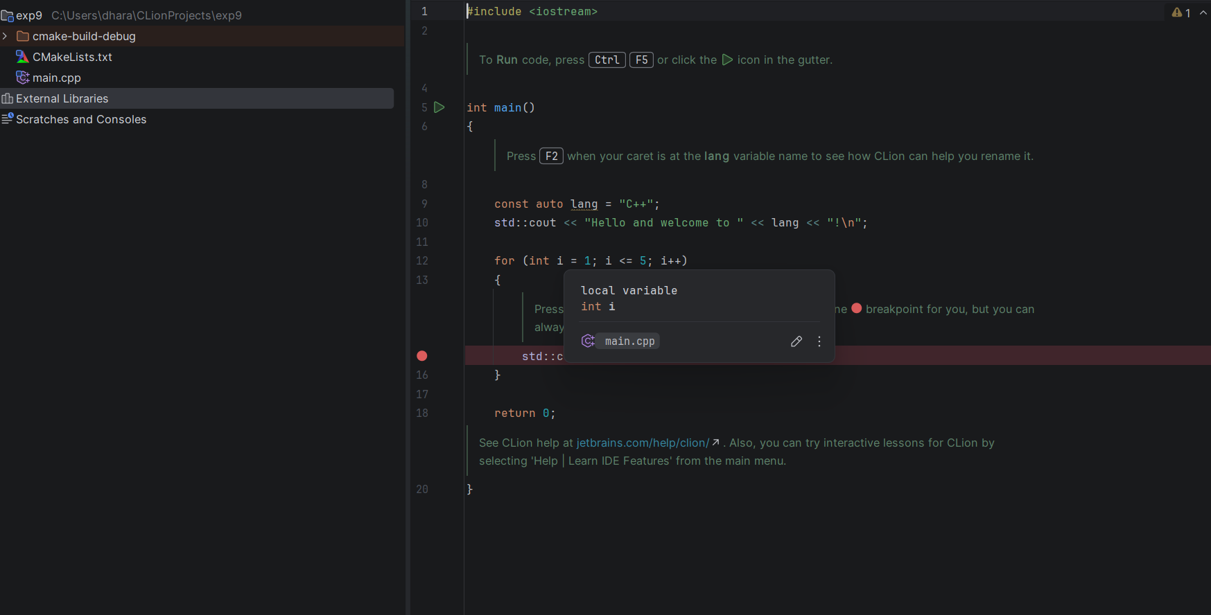

10. Illustrate the concept of inter-process communication using message queue with a C
program.
/* IPC using a Message Queue (Windows Mailslot) */
#include <stdio.h>
#include <string.h>
#include <windows.h>

#define MSG_SIZE 100
#define SLOT_NAME "\\\\.\\mailslot\\DemoMessageQueue"

/* Sender process: opens the mailslot and posts messages */
int run_sender(void) {
HANDLE hSlot = CreateFileA(SLOT_NAME, GENERIC_WRITE, FILE_SHARE_READ,
NULL, OPEN_EXISTING, FILE_ATTRIBUTE_NORMAL, NULL);
if (hSlot == INVALID_HANDLE_VALUE) {
printf("[Sender ] Cannot open mailslot (%lu)\n", GetLastError());
return 1;
}

const char *msgs[] = {
"Message 1: Hello from sender",
"Message 2: Message queues keep messages in order",
"Message 3: This is the last message",
"quit"
};

for (int i = 0; i < 4; i++) {
DWORD written;
WriteFile(hSlot, msgs[i], (DWORD)strlen(msgs[i]) + 1, &written, NULL);
printf("[Sender ] Sent: \"%s\"\n", msgs[i]);
Sleep(300);
}

CloseHandle(hSlot);
return 0;
}

/* Receiver process: creates the mailslot, starts the sender, reads messages */
int run_receiver(const char *exePath) {
HANDLE hSlot = CreateMailslotA(SLOT_NAME, 0, MAILSLOT_WAIT_FOREVER, NULL);
if (hSlot == INVALID_HANDLE_VALUE) {
printf("[Receiver] CreateMailslot failed (%lu)\n", GetLastError());
return 1;
}
printf("[Receiver] Message queue created. Waiting for messages...\n");

char cmd[MAX_PATH + 32];
snprintf(cmd, sizeof(cmd), "\"%s\" sender", exePath);

STARTUPINFOA si;
PROCESS_INFORMATION pi;
ZeroMemory(&si, sizeof(si));
si.cb = sizeof(si);
ZeroMemory(&pi, sizeof(pi));

if (!CreateProcessA(NULL, cmd, NULL, NULL, FALSE, 0, NULL, NULL, &si, &pi)) {
printf("[Receiver] CreateProcess failed (%lu)\n", GetLastError());
CloseHandle(hSlot);
return 1;
}

char buffer[MSG_SIZE];
while (1) {
DWORD bytesRead = 0;
if (!ReadFile(hSlot, buffer, sizeof(buffer), &bytesRead, NULL)) {
printf("[Receiver] ReadFile failed (%lu)\n", GetLastError());
break;
}
if (strcmp(buffer, "quit") == 0) {
printf("[Receiver] Quit message received. Exiting.\n");
break;
}
printf("[Receiver] Received: \"%s\"\n", buffer);
}

WaitForSingleObject(pi.hProcess, INFINITE);
CloseHandle(pi.hProcess);
CloseHandle(pi.hThread);
CloseHandle(hSlot);
printf("[Receiver] Message queue closed. Done.\n");
return 0;
}

int main(int argc, char *argv[]) {
if (argc > 1 && strcmp(argv[1], "sender") == 0)
return run_sender();
return run_receiver(argv[0]);
}
